**EGERTON UNIVERSITY**



**FACULTY OF SCIENCE**

**DEPARTMENT OF COMPUTER SCIENCE**

**SOFTWARE DESIGN DOCUMENT FOR**

**ORGANIZATIONAL PROCURMENT MANAGEMENT SYSTEM**

**PREPARED BY: JOSHUA ASIACHI MURUNGA**

**REG. NO.: SP13/21799/14**

**PROJECT SUPERVISOR: MR. KIMANI NJOROGE**

**PROJECT COORDINATOR: DR. -ING WILFRED G. GIKARU**

**DATE: 26 MAR 2018**

**VERSION: 1.0**

**TABLE OF CONTENTS**

**1.0** **INTRODUCTION** 1

**1.1** **PURPOSE AND SCOPE** 1

**1.2** **PROJECT EXECUTIVE SUMMARY** 1

**1.2.1** **SYSTEM OVERVIEW** 1

**1.2.2** **DESIGN CONSTRAINTS** 5

**1.2.3** **FUTURE CONTINGENCIES** 5

**2.0** **SYSTEM ARCHITECTURE** 6

**2.1** **SYSTEM HARDWARE ARCHITECTURE** 6

**2.2** **SYSTEM SOFTWARE ARCHITECTURE** 7

**2.3** **INTERNAL COMMUNICATIONS ARCHITECTURE** 11

**3.0** **FILE AND DATABASE DESIGN** 11

**3.1** **DATABASE MANAGEMENT SYSTEM FILES** 11

**3.2** **NON-DATABSE MANAGEMENT SYSTEM FILES** 14

**4.0** **HUMAN-MACHINE INTERFACE** 14

**4.1** **INPUTS** 15

**4.2** **OUTPUTS** 18

**5.0** **DETAILED DESIGN** 20

**5.1** **HARDWARE DETAILED DESIGN** 20

**5.2** **SOFTWARE DETAILED DESIGN** 20

**5.3** **INTERNAL COMMUNICATIONS DETAILED DESIGN** 22

**6.0** **EXTERNAL INTERFACES** 22

**6.1** **INTERFACE ARCHITECTURE** 22

**6.2** **INTERFACE DETAILED DESIGN** 22

**7.0** **SYSTEM INTEGRITY CONTROLS** 22

## **INTRODUCTION**

## **PURPOSE AND SCOPE**

This software design document describes the architecture and system design of the organizational procurement management system. The E-Procurement system is a reliable, convenient and efficient means of handling procurement procedures within the purchasing department. This design will detail the implementation of the requirements as defined in the Software Requirements Specification for the organizational procurement management system. This document is an overview of the system dependencies and basic implementation of the system. This document can be used by users of the system, system administrators, reviewers and anyone interested in the functioning of the system. This document however is not an API guide or anything of the sort. There is no code discussed here, neither is this a tutorial on any programming language or area.

## **PROJECT EXECUTIVE SUMMARY**

## **SYSTEM OVERVIEW**

Modern enterprises’ procurement demands have constantly increased over the years and the traditional modes of operation has failed to effectively meet this demand. With time efficiency being a sort after aspect in modern organizations to ensure its maximum productivity, various management techniques have been implemented to see this through. This document describes the design of one such technique that the purchasing department of any organization can implement. This technique comes in the form of a procurement management system, which is an online portal where the suppliers, departmental employees and the purchasing department can communicate in relation to the required goods and services.

The system can be over simplified by defining as two major modules, a tender and procure module and a requisite module. The first is where the actual procurement work is done. It involves setting up invitation to tender and also direct procurement of goods. By invitation to tender, the organization may need some goods or services to be provided. If the available suppliers in the system do not offer any of the services, then the purchasing department may set up a tender inviting prospective suppliers to do the job. The registered suppliers in the system will then bid on the tender and a particular supplier will be awarded the tender based on the supplier research and selection by the organization. A contract is offered to the supplier by the organization and should the supplier accept it, the tender is closed for application and set to active. The administrator of the system can manage the setting up of tenders, their cancellation or their renewal. The administrator can also manage the current active contracts as to the organizations wishes. When we say direct procurement, here the organization through the administrator purchases the advertised goods by the suppliers depending on what the organization seeks. Each registered supplier in the system has a chance to show off their portfolio through uploading the product information in the portal like an e-commerce application. These products are available for viewing by the organization who can then send a purchase request to the supplier who can choose to either accept or deny. Should they accept, an agreement between the supplier and the organization is reached on the various delivery requirements.

The second major module lies between the organization’s purchase department and its other departments. Each department in the organization has a head who is responsible for approving the department’s procurement needs. At the lowest level of this structure is the departmental employee who sends a requisition to the head of department for approval. Should the head of department approve of the request, the requisition is forwarded to the purchasing department where the administrator can choose to either set up a tender invitation or do a direct procurement and the cycle continues.

In total there are four types of users, that is, the supplier, the head of department, the departmental employee and the administrator. All these users have a set of privileges in which they can use to carry out their activities in the system. All operations go through the purchasing department which is managed by the administrator who is some sort of super user. The administrator creates the head of department accounts, can remove supplier accounts, is responsible for the tenders among other responsibilities. The following diagram is a simplified version of the entire system and how each user interacts with it.

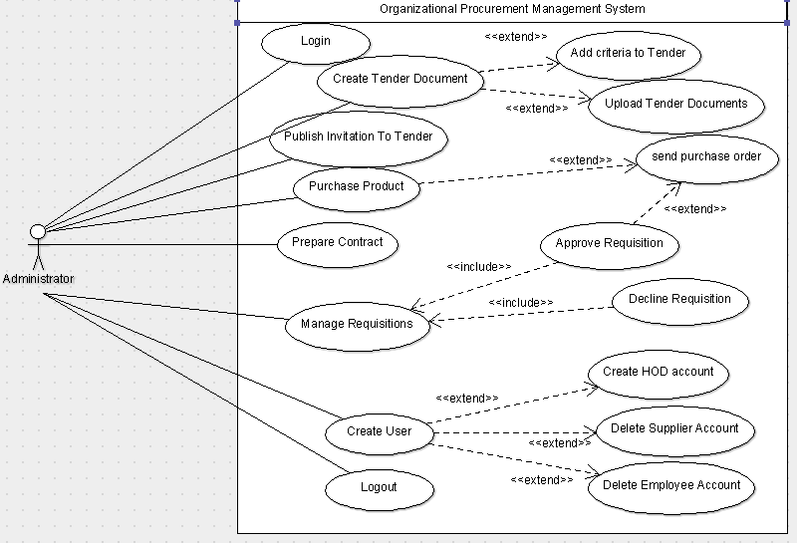

**Fig. 1.0:** *System Administrator Use Case Diagram*

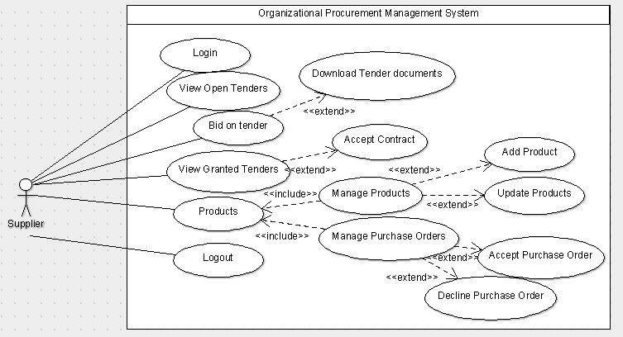

**Fig. 1.1:** *Supplier Use Case Diagram*

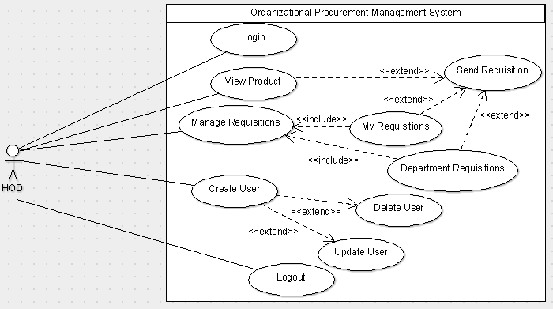

**Fig. 1.2:** *HOD Use Case Diagram*

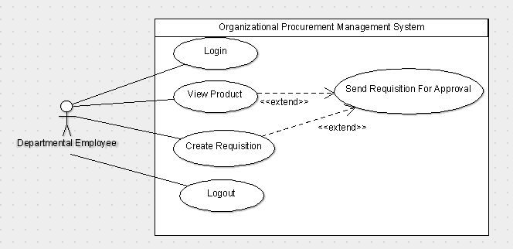

**Fig. 1.3:** *Departmental Employee Use Case Diagram*

## **DESIGN CONSTRAINTS**

The system is designed to operate in an environment as described in the Software Requirements Specification document for the organizational procurement management system. This will ensure that the complete functionalities of the system are running as required.

The system is also programmed with Java EE which is a modern and more advanced form of programming that creates responsive and highly advanced web applications with exceptional security.

The system is also designed to use PostgreSQL database which requires a fairly adequate amount of memory that is already accounted for in the operating environment.

Being a web application, the entire system is online and requires internet connection in order to operate. All the users will be able to access the system through the specified URL where they can carry out their respective operations.

## **FUTURE CONTINGENCIES**

Should the recommended database management system be too memory intensive or unfamiliar with the system maintenance team or even the requirements change, then the system is designed to make way for the easy shift of the database management system.

Even though the system is entirely secure, new security measures could also be implemented into the system to ensure its safety from attacks and attempts to violate the security of the system.

Since procurement requires constant communication between the supplier and the organization, a great addition to the system would be a live chat functionality for easy communication between the two entities and also between the organization’s other departments and the purchasing department.

## **SYSTEM ARCHITECTURE**

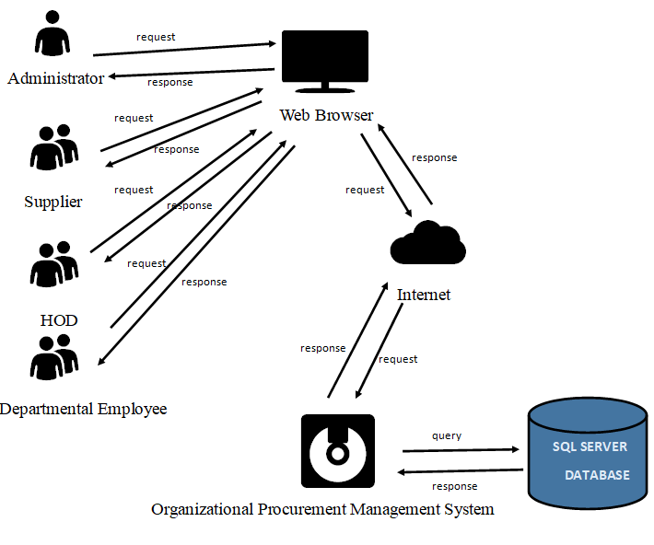

**Fig. 2.0:** *System architecture for organizational procurement management system*

## **SYSTEM HARDWARE ARCHITECTURE**

The system is housed in a server which comprises of a central processing unit, main memory and secondary memory as its main components. Each of these components has a specification that will suit the needs of the system. These specifications have been defined in the system requirements document for organization procurement management system. The server communicates with a SQL database server that is used to store the information of the system.

The server is connected to the internet where the system can be interacted with through a user interface that can be accessed from a web browser by entering the respective link.

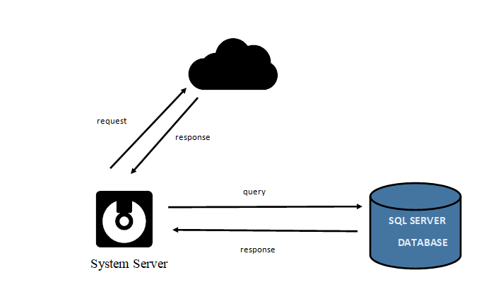

**Fig. 2.1:** *Hardware architecture for organizational procurement management system*

## **SYSTEM SOFTWARE ARCHITECTURE**

The organizational procurement management system is broken up into two major components: a client-side application and a server-side application connected to a PostgreSQL database.

The client-side application is also separated into two parts: the functional component and the graphical component. The functional component forms the core of the system. It fetches data from server and posts data to server. The graphical component, as the name implies, is simply the graphical user interface. It provides all of the buttons, text boxes, and other onscreen elements which allow the user to access all of the features provided by the application.

The following are the software components that will be used:

1. NetBeans – The IDE that will be used to develop the system.
2. Web browser, for example Mozilla Firefox, Chrome or any other according to clients’ preferences.
3. Tomcat server – It is an application server from Apache Software Foundation that executes java servlets and renders web pages that include JSP coding available upon users’ request.
4. PostgreSQL server – It is a DBMS (Database Management Server) that is used to manage the database files involved in the systems allowing data storage and access.

Below are activity diagrams that only shows the top-level communication between the system and external entities. It demonstrates how the organizational procurement management system interacts with some of the external entities such us the suppliers, administrators, head of department and departmental employees.

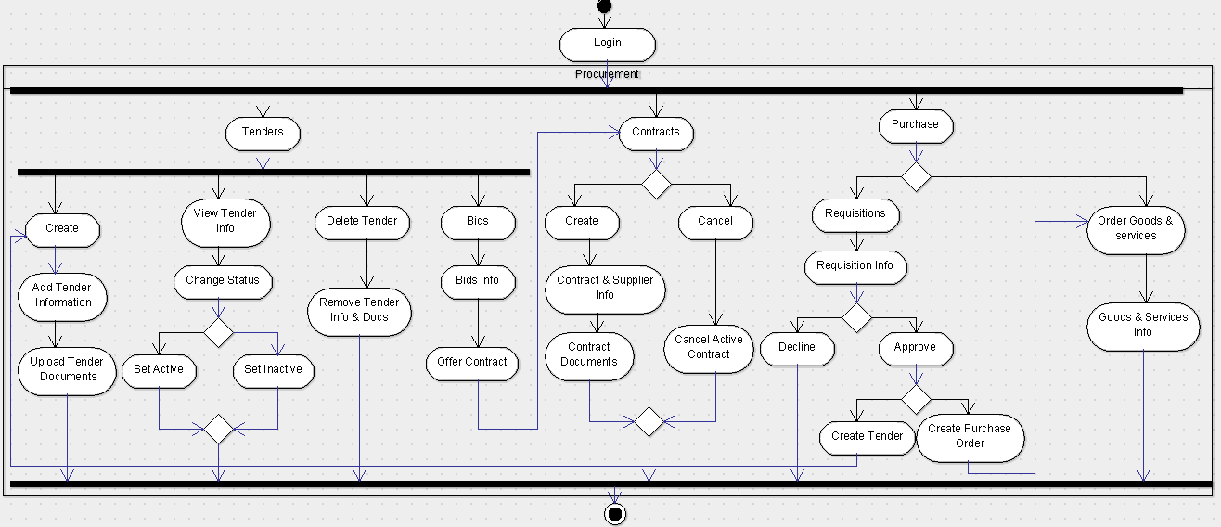

**Fig. 2.2:** *Administrator activity diagram Part 1 of 2*

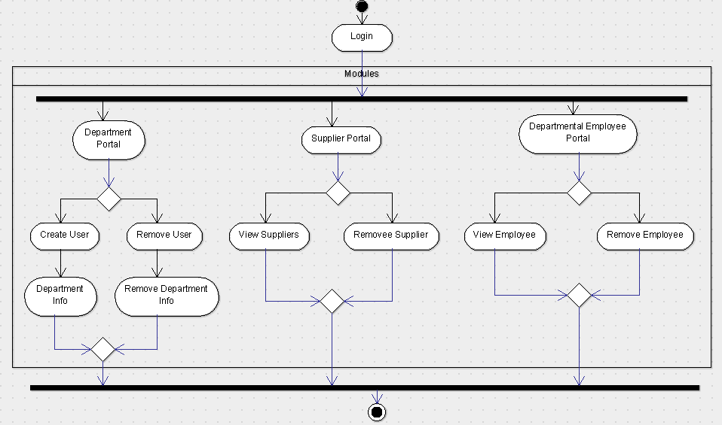

**Fig. 2.3:** *Administrator activity diagram Part 2 of 2*

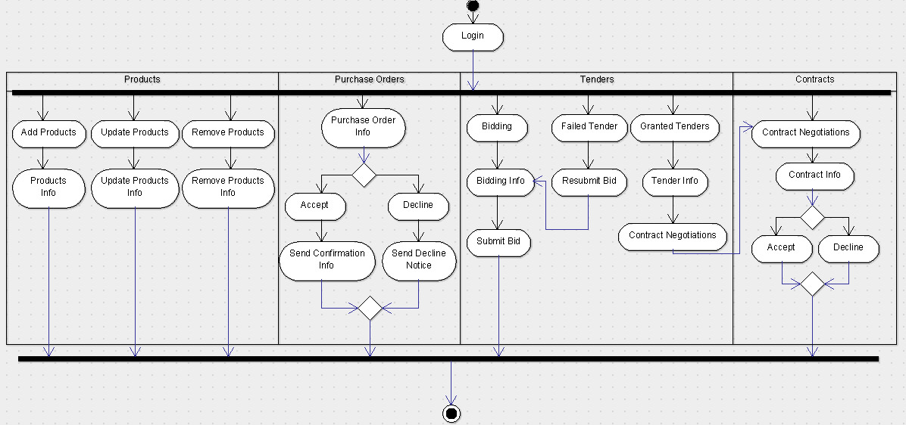

**Fig. 2.4:** *Supplier activity diagram*

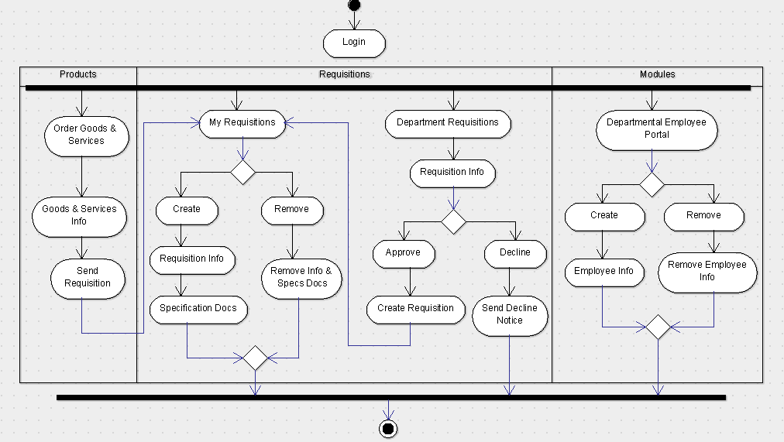

**Fig. 2.5:** *Head of department activity diagram*

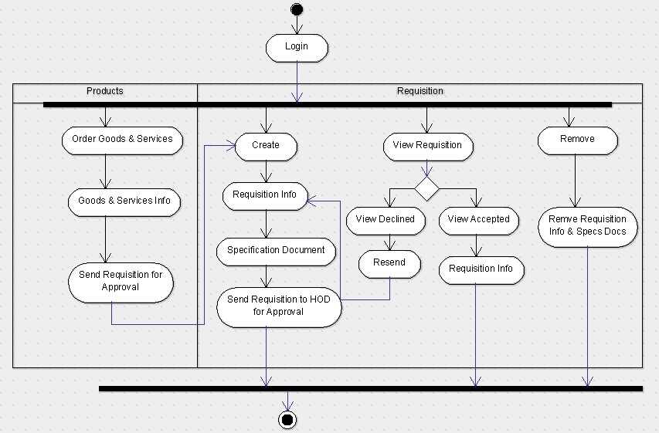

**Fig. 2.6:** *Departmental employee activity diagram*

## **INTERNAL COMMUNICATIONS ARCHITECTURE**

The communication process of the system will be achieved only in internet availability that will enable communication between the application and the database during retrieval of data from database and communication between various modules of the system. A web browser is used as the interface to make the request to the database and also render the response back to the user of the requested resource. The protocol used to ensure proper communication between the browser and server hosting the system is HTTP.

## **FILE AND DATABASE DESIGN**

## **DATABASE MANAGEMENT SYSTEM FILES**

The database, stored in the server-side, has been created to Store the information required for the proposed application. Description of the database tables is given below.

**Table 1: Users table details**

|  |  |  |  |  |
| --- | --- | --- | --- | --- |
| **Columns** | **Constraint** | **Data type** | **Size** | **Description** |
| userid | Primary Key | Integer (AI) | 11 | Uniquely identify user |
| firstname |  | Character Varying | 15 | First name of user |
| lastname |  | Character Varying | 15 | Last name of user |
| username |  | Character Varying | 20 | Username of user |
| password |  | Character Varying | 255 | Password of user |
| email |  | Character Varying | 50 | e-mail of user |
| company |  | Character Varying | 50 | Company user works |
| phonenumber |  | Character Varying | 10 | Mobile or telephone number of user |
| address |  | Character Varying | 20 | Address of user’s company |
| department |  | Character Varying | 15 | Department user works in company |
| jotitle |  | Character Varying | 15 | Job title of user in company |
| role |  | Smallint | 4 | Role of user |

**Table 2: Tenders table details**

|  |  |  |  |  |
| --- | --- | --- | --- | --- |
| **Columns** | **Constraints** | **Data type** | **Size** | **Description** |
| tenderid | Primary Key | Integer (AI) | 11 | Uniquely identify tender |
| refno |  | Character Varying | 50 | Uniquely identify tender |
| title |  | Character Varying | 100 | Title of tendering document |
| category |  | Character Varying | 20 | Category of tender document |
| startdate |  | date |  | Date when tender is opened |
| enddate |  | date |  | Date when tender is closed |
| status |  | smallint | 4 | Status of tender |
| description |  | Text |  | Description of tender |
| bidid | Foreign Key | Integer | 11 | Identify a bid |

**Table 3: Bids table details**

|  |  |  |  |  |
| --- | --- | --- | --- | --- |
| **Columns** | **Constraints** | **Data type** | **Size** | **Description** |
| bidid | Primary Key | Integer (AI) | 11 | Uniquely identify bid |
| biddate |  | date |  | Date of received bid |
| status |  | smallint | 4 | Status of bid |
| userid | Foreign Key |  | 11 | Identify of user/ company |

**Table 4: Contracts table details**

|  |  |  |  |  |
| --- | --- | --- | --- | --- |
| **Columns** | **Constraints** | **Data type** | **Size** | **Description** |
| contractid | Primary Key | Integer (AI) | 11 | Uniquely identify contract |
| refno |  | Character Varying | 50 | Uniquely identify contract |
| status |  | smallint | 4 | Status of contract |
| value |  | Integer | 11 | Amount value of contract |
| startdate |  | date |  | Date of starting contract |
| enddate |  | date |  | Date of ending contract |
| userid | Foreign Key | integer | 11 | Identify of user/ company |

**Table 5: Requisitions table details**

|  |  |  |  |  |
| --- | --- | --- | --- | --- |
| **Columns** | **Constraints** | **Data type** | **Size** | **Description** |
| requisitionid | Primary Key | Integer (AI) | 11 | Uniquely identify requisition |
| product |  | Character Varying | 20 | Name of product |
| category |  | smallint | 4 | Category of product |
| value |  | Integer | 11 | Amount value of product |
| supplier |  | Character Varying | 20 | Supplier of product |
| description |  | Text |  | Description of product |
| status |  | smallint | 4 | Status of requisition |
| userid | Foreign Key | Integer | 11 | Identify of user |

**Table 6: Products table details**

|  |  |  |  |  |
| --- | --- | --- | --- | --- |
| **Columns** | **Constraints** | **Data type** | **Size** | **Description** |
| productid | Primary Key | Integer (AI) | 11 | Uniquely identify product |
| name |  | Character Varying | 25 | Name of product |
| category |  | smallint | 4 | Category of product |
| price |  | integer | 11 | Price value of product |
| manudate |  | date |  | Manufactuer date of product |
| description |  | text |  | Description of product |
| userid | Foreign Key | integer | 11 | Identify of user/ supplier |

**Table 7: Purchase orders table details**

|  |  |  |  |  |
| --- | --- | --- | --- | --- |
| **Columns** | **Constraints** | **Data type** | **Size** | **Description** |
| poid | Primary Key | Integer (AI) | 11 | Uniquely identify purchase order |
| productid | Foreign Key | integer | 11 | Identify of product |
| productprice | Foreign Key | integer | 11 | Identify of product price |
| qty |  | integer | 11 | Quantity of product |
| total |  | integer | 11 | Total price of purchase order |
| podate |  | date |  | Purchase order date |
| category | Foreign Key | smallint | 4 | Identify of product |
| description |  | text |  | Description of product |
| suppier | Foreign Key | Character varying | 25 | Identify of user/ supplier |
| status |  | smallint | 4 | Status of purchase order |

## **NON-DATABSE MANAGEMENT SYSTEM FILES**

The organizational procurement management system also involves file system of storage. This will be implemented in storing tender and any additional contract documents. System logs are also stored in text file format. All these files are stored in the secure web server in a given specified directory.

## **HUMAN-MACHINE INTERFACE**

The system can be generalized to have four sections from a user interface perspective. This is based on the four different types of users of the system, those being the administrator, the supplier, the head of department and the departmental employee. Each of these users have their own specified modules which they can operate. The administrator is pre-created account which is rolled out with the system. The administrator acts as the super user and has the highest privileges in the system. The supplier is the only user who can create their own account and are limited to the functions they can perform. The head of department’s account is created by the administrator and the head of department in turn creates the departmental employee who has the lowest privileges in the system. All user information is stored in the database which the system uses to fetch data during authentication and assigning the respective functionalities based on the user roles.

## **INPUTS**

The organizational procurement management system inputs all data through data entry by mostly text fields and drop down lists. All the necessary data is recorded and securely stored in the database server which can be retrieved and used throughout the system. Before data is recorded to the database, they undergo some form of verification in order to ensure that the data stored in the database is consistent and reliable. Each data entry field has its own acceptable value such as numerical value, text values etc. For instance, in the sign up page for the supplier, all fields are mandatory and no registration will take place if they fail to enter one of the fields. Phone numbers is one example of a constrained value that is expected from the user. It should be numerical and should have a maximum length of 10 values in the form of 0712345678. Failure to comply with these input standards, the system will prompt the user to correct the errors before the system can complete the registration process. upon successful registration, the system notifies the use that the process was successful and they can use their credentials to access the system. Sensitive information such as the passwords to user accounts are encrypted before they are stored in the database to prevent them from leaking out in the case that some unauthorized individual gains access to the database. Other user registration is quite similar except the respective accounts are created by the user with higher authority. All users however gain access through the login form by entering the correct credentials which the system verifies that the user has the valid information to access the system. If not, an error message will be displayed indicating that incorrect credential have been entered.

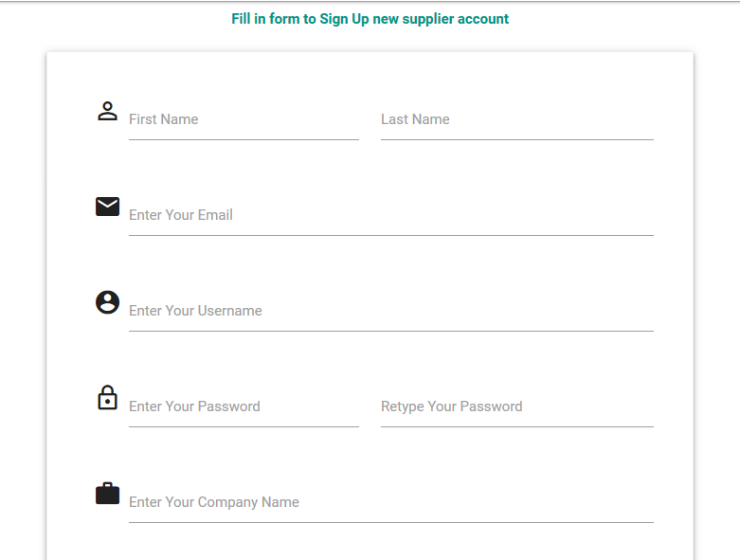

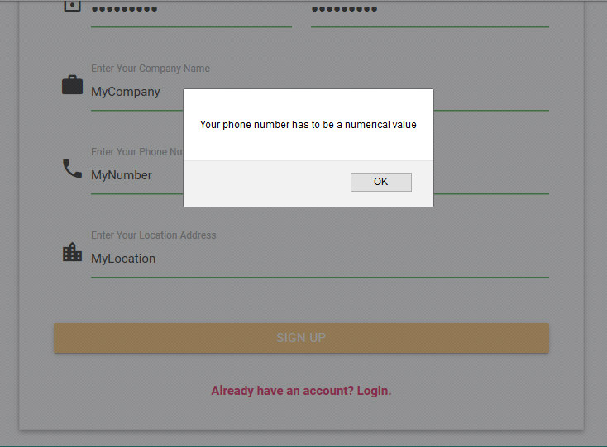

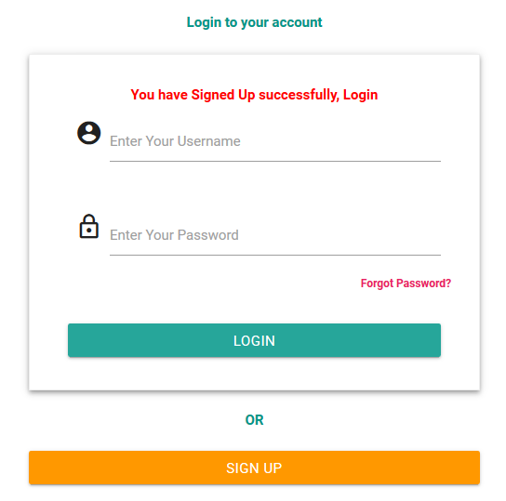

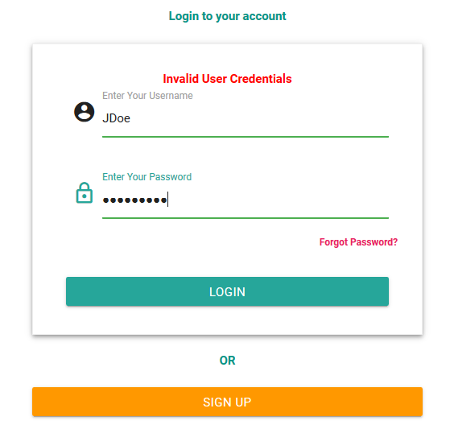

## **OUTPUTS**

The system’s main interface is a dashboard for all users. Each of the different user types have a different dashboard displaying the most crucial and immediate information that the user may be looking for. Each of the user types can only view the information that they are limited to.

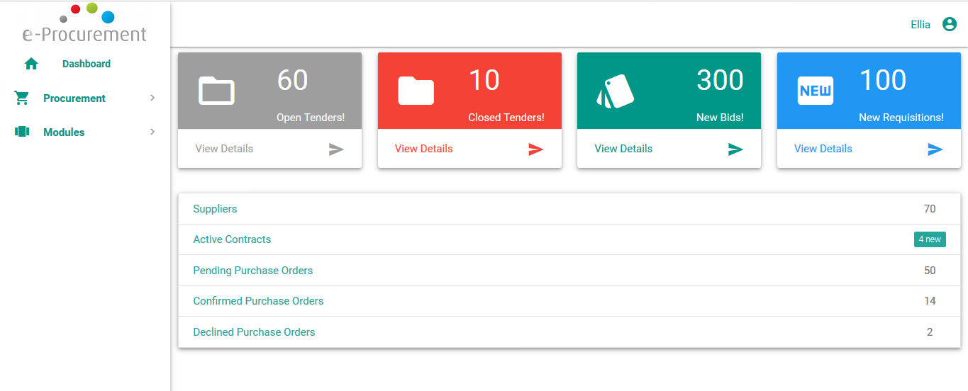

**Fig. 4.0:** *An administrator dashboard*

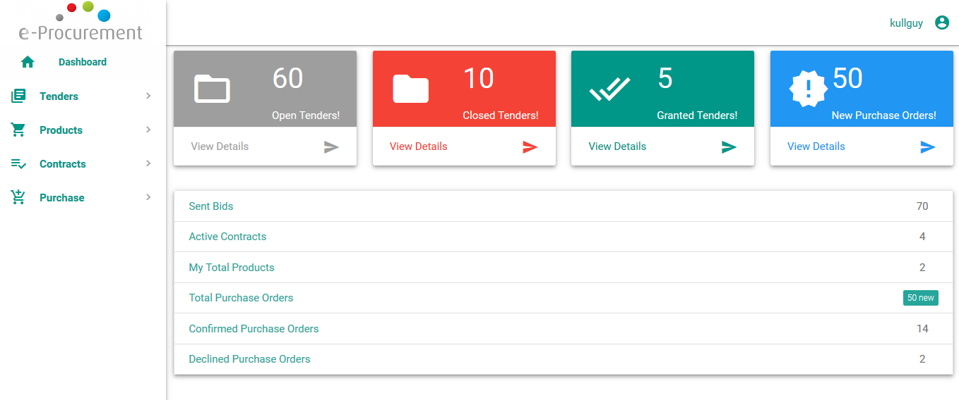

**Fig. 4.1:** *A supplier dashboard*

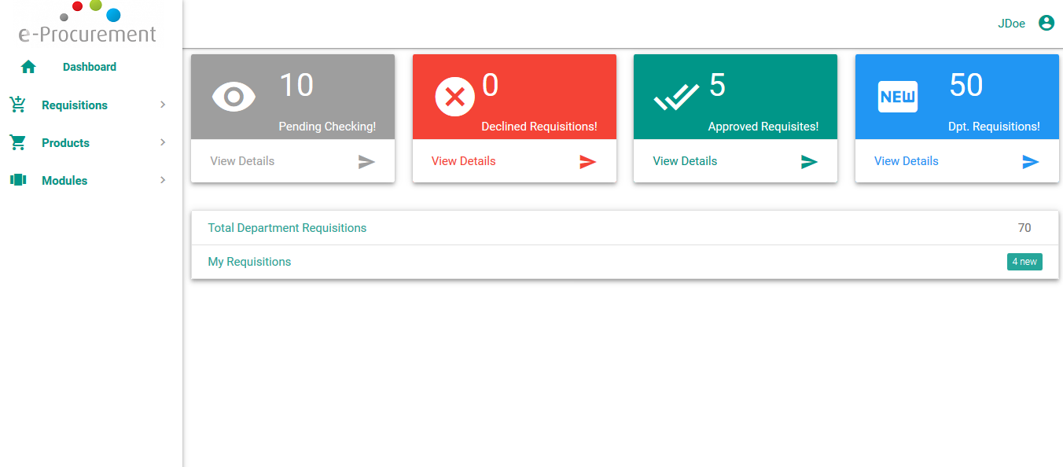

**Fig. 4.2:** *A head of department dashboard*

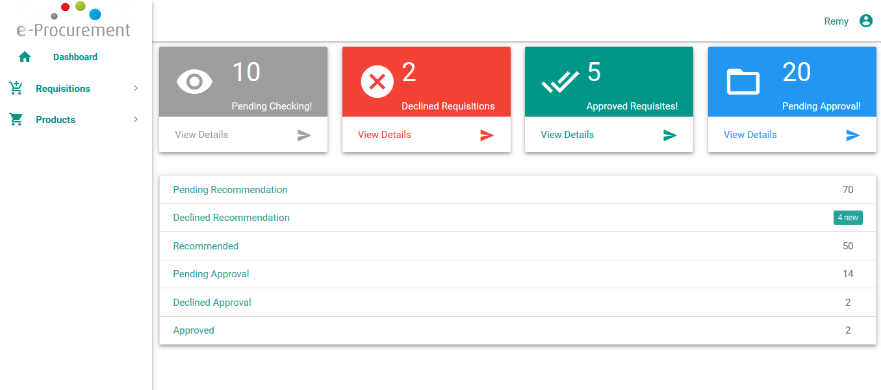

**Fig. 4.3:** *A departmental employee dashboard*

Apart from these immediate data, the system will display information depending on the user’s need. Most information will be summarized and displayed in a tabular format where the user can click on a link and be able to view the full details of what they wish to see.

## **DETAILED DESIGN**

## **HARDWARE DETAILED DESIGN**

The required hardware components in order to run the system include a web server with the requirements as specified in the system requirements document for the organizational procurement management system. The web server should also have the recommended database management system installed. Other hardware components include the network switch, routers and a client PC or digital devices that have web browsers installed in them.

## **SOFTWARE DETAILED DESIGN**

The system will contain several modules to ensure its full functionality as expected. These modules and their functionality are as follows:

1. **Registration**

This module handles user registration to the system. It involves mandatory signups for all users in order to access the system. When the system is deployed, an initial administrative account is bundled with it. For other users, the suppliers have been presented with a registration form, which upon successful completion, will gain access to a supplier account while the head of department account is registered by the administrator and the departmental employee account is registered by the head of department.

1. **Login**

The login module facilitates security in that, it is through this module that all users, administrator, supplier, head of department and departmental employee, are authenticated before they can access the system. The login module depends on the registration module since only registered users can use the login module to successfully access the system.

1. **Procurement**

This module deals with the agreeing terms and acquiring goods, services or works from the supplier. The administrator looks for a product the organization wishes to procure and when the product is located, the administrator sends a purchase order to the respective supplier who can decide whether to accept or decline the order,

1. **Tender**

This module deals with inviting suppliers to supply goods, services or works to the organization. If the product the organization wishes to procure is not readily available in the system, the administrator may create an invitation to tender where the suppliers will enter a bidding contest and the organization will determine which supplier will be awarded the tender and offered a contract.

1. **Bidding**

This module is dependent on the tender module. It involves suppliers sending bids to the open invitation to tender that the organization has advertised.

1. **Requisition**

This module is limited to the head of department and departmental employee users. It involves sending a list of items/ products that a particular department in the organization needs to the purchasing department. However, requisitions from departmental employees have to be approved by the head of department before they are forwarded to the purchasing department.

1. **Product**

This is a supplier module. It involves suppliers uploading their products to the system. These products can be viewed by the administrator as well as the head of department and departmental employee.

## **INTERNAL COMMUNICATIONS DETAILED DESIGN**

The internal flow of information between the system modules is necessary in order for the system to fully perform its functionality. This is facilitated by the communication between class objects under different modules through the HTTP protocol.

The system also communicates with the database through various user interfaces. This facilitates some major functionalities in the system. One is that, data will be able to be stored in the database by capturing user data through these interfaces. The other is that, these interfaces can also fetch the stored data from the database and availing it for actions ranging from simple viewing to updates and deletions of these data.

## **EXTERNAL INTERFACES**

## **INTERFACE ARCHITECTURE**

External interfacing helps facilitate communication between the system and other external systems. Since the communication is via internet, TCP/IP protocol will be used. To ensure proper external interfacing, an active link of communication between the client, server and database PCs components and any other external systems that the application will be exchanging information with is very vital. The network architecture is not much of a consideration.

## **INTERFACE DETAILED DESIGN**

Data does not need to be reformatted before transmission or reception over the interface between two different communicating modules since communication is through TCP/IP. The protocol regulates data exchange over the interface and also dynamically handles errors arising from the data exchange. A brief error description will also be provided to the user in HTML format.

## **SYSTEM INTEGRITY CONTROLS**

To ensure a strong system base security, the proposed system will implement data encryption before any piece of critical and confidential information or data is submitted and stored in the database. Successful protection of data will ultimately ensure integrity of the system. Thus integrity checks need to be employed in order to ensure correctness of stored data and accountability for every system user. The following security controls will be implemented to ensure integrity of the system:

1. **Authorization control**. This ensures that users can only access data that belongs to their roles and that they have the required permissions.
2. **Database restriction.** Users can only update data that they have supplied. Update of data affecting the whole system will only be restricted to the system administrator. Data deletions will also be limited to certain classes of users based on the user roles.
3. **Integrity control**. This ensures that data stored in the database cannot be violated or altered by any unauthorized parties in any way whatsoever.
4. **Authenticity control**. This aspect of security will verify user credentials at the time of login into the system. This ensures that only authorized users are allowed to access the system.
5. **Confidentiality control**. This is a security technique that prohibits unauthorized access of personal information.
6. **Audit Procedures**. There shall be a system audit mechanism that automatically collects data based on user transactions to monitor user activities in the system. The audit will be available to the system administrator in form of log information detailing user activities, user identifications and time so as to enhance accountability.
7. **Client and server side validation**. This will ensure that no wrong inputs are accepted into the system.

The system being web application is open to a variety of attacks. However, security measures have been placed to prevent attacks such as Cross Site Scripting attacks and Cross Site Request Forgery attacks.